On-Prem Installation Components and hardware requirements

Overview
eSignet operates as a collection of microservices hosted within Kubernetes clusters to ensure scalability, modularity, and high availability.
This guide is applicable only for eSignet version 1.5.0 and above.
- The deployment process includes the following key components and configurations:
  - Wireguard: Wireguard is used as a trust network extension to access the admin, control, and observation pane along with on-field registration client connectivity to the backend server.
  - Nginx Server: eSignet uses the Nginx server for:
    - SSL termination
    - Reverse Proxy
    - CDN/Cache management
    - Load balancing
  - Kubernetes (K8s) Cluster: Kubernetes (K8s) cluster creation, configuration and administration of same.
    - K8 cluster is created using the Rancher and rke tools.
    - K8 cluster essentially used in ref-impl architecture:
      - Observation K8 cluster
      - eSignet application K8 cluster
  - Cluster Configurations:
    - Ingress Setup: For exposing application services outside the K8s cluster.
    - Storage Class Setup: This is used to set up the storage class for persistence in the K8 cluster.
    - Logging System: Continuously scrapes logs from all pods as needed.
    - Monitoring System: Continuously monitors logs and generates graphs to better manage the application and cluster.
    - Alerting: Users are identified about crucial events as and when needed.
  - Observation K8 cluster contains:
    - Rancher Ui: application used to create and manage the k8 cluster. This is needed once for an organization as it can manage multiple dev, qa, and prod k8 clusters easily.
    - Kecloak: IAM tool used for defining RBAC policies for allowing access to Rancher.
  - eSignet cluster: This cluster hosts all eSignet components, along with certain third-party components, to ensure the cluster's security, APIs, and data.
- eSignet Pre-requisites:
- These are the services required to deploy multiple eSignet modules:
  - eSignet-prerequisites: Servicess required for esignet-service and oidc-ui deployment.
  - eSignet-mock-prerequisites: Servicess required for mock-relying-party and mock-relying-party-ui deployment.
  - eSignet-signup: Services required for esignet-signup-service and esignet-signup-ui deployment.
- eSignet Services deployment:
  - esignet-service and oidc-ui deployment.
  - Onboarding MISP partner for eSignet service.
  - mock-relying-party-service and mock-relying-party-ui deployment.
  - Onboarding mock-relying-party.
  - esignet-signup-service and esignet-signup-ui deployment.
  - Onboarding MISP partner for esignet-signup-partner.

Architecture
The diagram below illustrates the deployment architecture of the eSignet, highlighting secure user access via VPN, traffic routing through firewalls and load balancers, and service orchestration within a Kubernetes cluster.
- Key Components: eSignet Service, OIDC UI, databases, and secure cryptographic operations via HSM.
- Deployment: Managed with Rancher, Helm charts, and a private Git repository.
- Monitoring: Ensured using Grafana and Prometheus for observability.
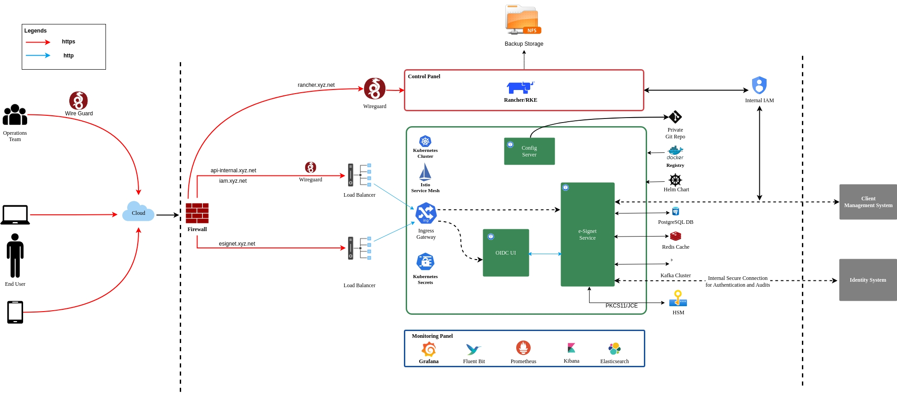
eSignet Architecture diagram

Hardware requirements
- Virtual Machines (VMs) can use any operating system as per convenience.
- For this installation guide, Ubuntu OS is referenced throughout.
